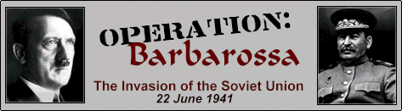

NOTES:

WW II – Operation Barbarossa and the North African Campaign

Operation Barbarossa:

http://www.youtube.com/watch?v=v_w8WS2drBQ&feature=related

- Germany’s unprovoked attack on her ally from the Russo-German non-aggression pact
- June 22, 1941 a 2000 mile front with initial surprise and success.
- Blitzkrieg worked well, and Stalin had purged his best officers from the army, which helped.
- Hitler was trying to get Lebensraum (living space), the wheat rich area of the Ukraine, and the oil from the Caucasus Mountain region.
- The Soviets used the Scorched Earth Policy, retreat and destroy everything that the Germans could use.
- Three main areas of attack: Leningrad, Moscow and Stalingrad.
- The Germans surrounded Leningrad for 2 and a half years but never defeated the city - They arrived on the outskirts of Moscow, but again, never defeated the city.
- The winter slowed the Nazi’s down, coldest in 50 years.
http://www.youtube.com/watch?v=UJ_9vETbamc&feature=related

- Hitler had miscalculated he thought it would be an 8-week war, avoiding the winter.
- In the spring of 1942, Hitler attacked again at Leningrad and Stalingrad.

NOTES:

The battle of Stalingrad: the turning point of WW II:

- Sept 1942, vicious street fighting, very heavy causalities on both sides.
- Hitler told his Generals to fight to the death, but Goering provided little air support.
- The Soviets encircled the Germans in the city, cutting off their supply lines. - 300,000 German troops finally surrendered.

The Significance of Stalingrad:

- The Nazis lost some of their best units.
- Hitler was denied the Caucasus oil fields.
- Lend-Lease supplies to the USSR were not cut off.
- This was the beginning of Eastern Liberation, Hitler’s biggest mistake and defeat.

http://www.youtube.com/watch?v=J4MhlJRkV94
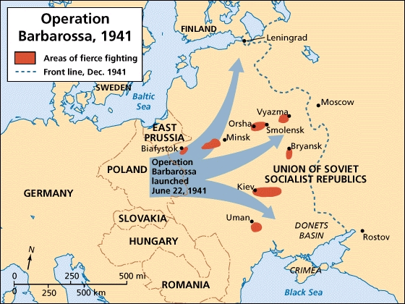

NOTES:
Why did Hitler fail in the USSR?

- Great distances: Russians could retreat using “Scorched earth” policy.
- Large population allowed the Russians to replace troops. The Soviets lost 2 million men in 1941, but carried on the fight.
- Winter: (50-60 below zero) frostbite, frozen equipment, inadequate clothing, over-extended German supply lines.
- Civilian and soldier courage and determination.
Germany now faced a 2 front war and the Americans were now in with Britain.

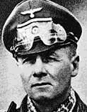
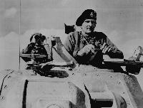
Battle for North Africa – Rommel vs. Montgomery

The Desert War – North Africa:

- Hitler wanted the Suez Canal – vital for shipping of oil.
- Oil was now very important because of mechanized war machines (tanks, planes, trucks).
- Italy had attempted to conquer North Africa, but had failed, and the Germans had to land to help out.
- German General Erwin Rommel (the Desert Fox) pushed the British forces all the way back to Alexandria.
- The crucial battle took place at El Alamein in Oct 1942, 60 miles from the Suez Canal.
- British General Montgomery upset Rommel and turned the German/ Italian force all the way back to Tunis, where they evacuated back to Italy.

NOTES:

- In Nov 1942, Operation Torch helped this out by and American/ British landing in Morocco.
- The two groups would pincer the Germans off the continent.

Significance of El Alamein:

- Suez Canal was safe.
- Hitler was denied oil from the Middle East.
- Proved Hitler could be beaten.

Significance of the North African Victory:

- This prepared the way for the liberation of Italy through the soft-underbelly of Europe.
- Middle East routes remained under Allied control.
- First USA action in the European theatre of war.

USA – pre WW II Entrance

- Roosevelt gave 50 destroyers to Britain for 8 Naval bases
- March 1941 the LEND-LEASE ACT was passed – this allowed the USA to give materials to powers friendly to the USA – this included Britain and the USSR

The Battle of the Atlantic

- Keeping Britain supplied
- The Nazis used Wolf packs of submarines to sink all vessels they could
- From 1941-1942, Hitler was sinking more ships than the Allies could build to replace

NOTES:
- In the spring of 1943 the tides turns in favor of the Allies. How?
- Sonar and long range aircraft
Convoys – anti-submarine weapons (depth charge) airstrikes on submarines
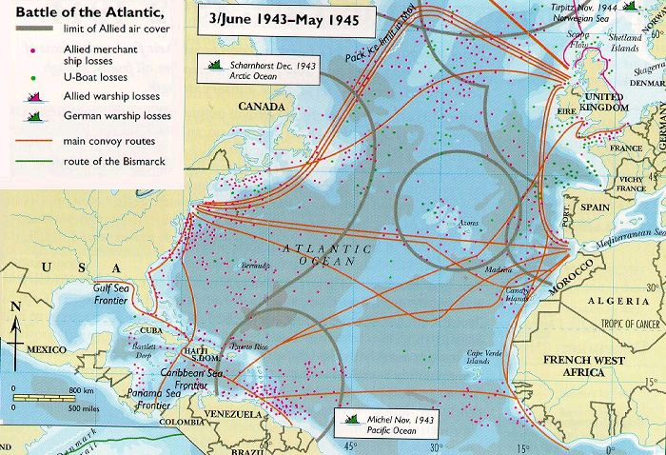

June-Aug 1943, 79 Nazi U-boats sunk; the Allies now controlled the Atlantic

The Italian Campaign – Operation Husky

- Stalin was upset about no second front to relieve pressure
- The West was not yet prepared, but had cleared out North Africa
- Sicily invasion on July 9, 1943 – amphibious assault
- Viscous fighting in tough terrain, slow Ita/Ger retreat
- During this fighting, the Italians disposed Mussolini as leader, and a new government announced Italy’s surrender
- BUT! – it was now the Allies vs. the Nazis in Italy. Canadian, British and American forces.
- http://www.youtube.com/watch?v=AgiYhWQErU0&feature=related

- Sept 9, 1943, the Allies land in Salerno
- The battles of Casino
- It would take until June 5, 1944 to take Rome
In May 1945, the war in Italy ended and Mussolini was hung for public viewing

The Significance of the Italian Campaign
- pre-requisite to liberate Europe
- it occupied Nazi troops from the west
- Attempted to show Stalin some support
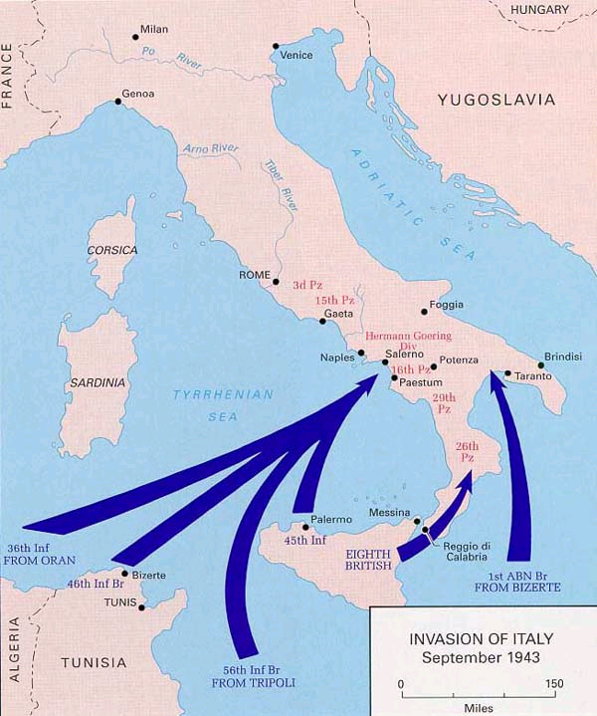

PRE-SECOND FRONT

NOTES:

- Strategic bombing by the Allies – Why? Kept some pressure up in the west, and limited the Nazis ability to conduct the war. Precision bombing of factories – area bombing of cities
- bombing was used to try and demoralize the enemy
- bombing was not very accurate until 1943 – new technology
- by the spring of 1944, the Allies were ready to liberate France
- Gen. Rommel, was put in charge of the Nazi coastal defenses of France
- Huge concrete bunkers, mined beaches, tank traps
The allies prepared their invasion in the south of England

- General EISENHOWER (USA) was made the Supreme Commander of the Allied Forces in Europe preparing Operation OVERLORD.
A 3,000,000 man force, also known as D-Day. 100,000 first day
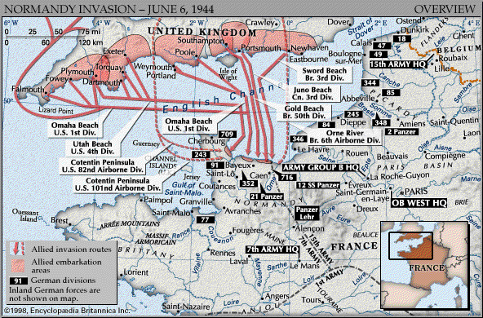

D-Day – Normandy, France – June 6, 1944

NOTES:

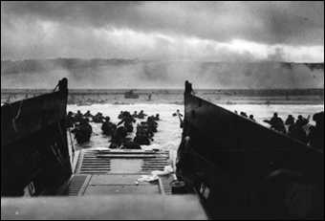
Beaches: Utah/Omaha – USA Gold/Sword – Britain Juno – Canada
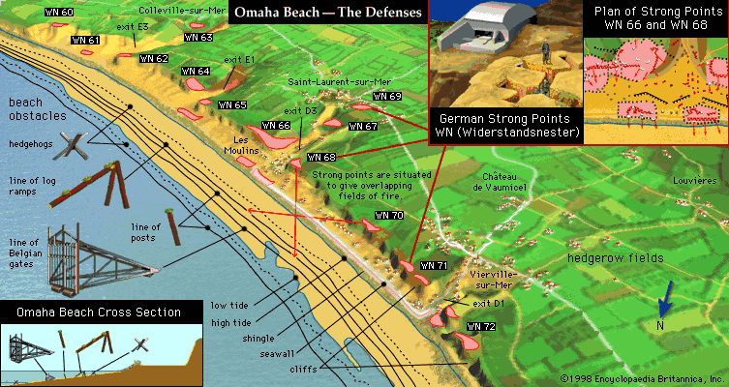

NOTES:
Final Drive to Berlin in the West – post Normandy landings

The Battle of the Bulge – the Ardennes – the Nazis found a weak point to exploit
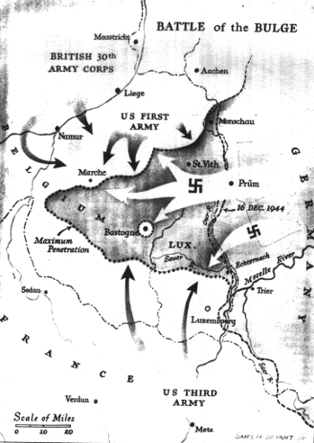

December 16: The Battle of the Bulge begins. Hitler sends a quarter million troops across an 85-mile stretch of the Allied front, from southern Belgium into Luxembourg. In deadly cold winter weather, German troops will advance some 50 miles into the Allied lines, creating a deadly "bulge" pushing into Allied defenses.

January: By the end of the month, the Battle of the Bulge ends. Over 76,000 Americans have been killed, wounded, or captured. The Allies regain the territory they held in early December.

NOTES:

- Allied bombers flew the skies unopposed
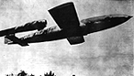
Germany now tried its V1 and V2 rockets – unmanned flying bombs aimed at London
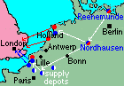
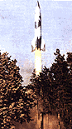

Final Drive to Berlin in the East

- after Stalingrad, the Nazis were in retreat on the Eastern Front
- July 1943, the battle of Kursk – the largest Tank battle ever fought
- 1944, the Red Army enters Poland
- they then break the siege at Leningrad, push into the Crimea and Finland - massive offensive, Romania falls to the Red Army, Danzig is taken early in 1945

NOTES:
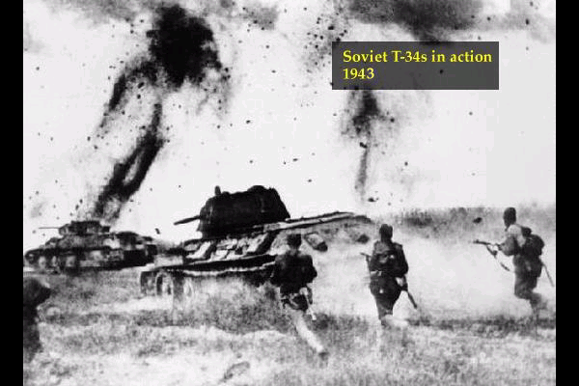

in April 1945, the Berlin offensive in launched – total brutality by the Red Army on Berlin’s citizens – murder, rape and destruction was common place – get back at Germany time!

- The Allies finally entered Germany, and in April 1945, USA and USSR forces met in Germany
- A great political battle was waged at Allied command about who should enter Berlin first
- April 30, 1945, Hitler commits suicide with his wife Eva Braun
- May 2, 1945 Berlin falls to the Soviet Red Army
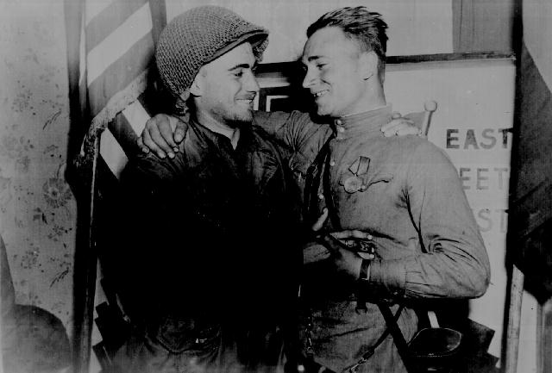
May 8, 1945 is VE Day – Victory Europe Day.

