The Holocaust

“Once I really am in power, my first and foremost task will be the annihilation of the Jews.”
- Adolf Hitler

- The Nazis used the Jews as the scapegoat for all of Germany’s economic and political problems.
- The Nazis theorized the extermination of the Jews by referring to Darwin’s Theory of Evolution, deriving a master race concept. Jews were genetically inferior.
- Goebbels pushed anti-Semitism through an all out propaganda campaign.
- Along with the extermination of approximately 6 million Jews, the Nazis also targeted:
- communists
- gypsies
- political leaders of opposition
- clergy (Catholic)
- intellectuals

- These individuals were sent to extermination camps where they were eliminated = genocide.
- Before their deaths, they were stripped of their possessions, confined to live in filthy barracks, subjected to horrendous medical tests, underfed, and forced to perform slave labor. Many were shot at random, and most were gassed to death and then cremated.
- The major camps were Dachau (opened in 1933), Buchenwald and Auschwitz.
- Central and Eastern European countries had a long tradition of anti-Semitism throughout history.

Timeline

- 1934 Nuremberg Laws: deprived Jews of citizenship, forming the legal basis for the exclusion of Jews from German society.
- 1938 Crystal Night: the burning of Jewish homes and synagogues
- 1940 – Polish Jews confined to ghettos
- 1941 – Germany attacks the USSR, and the Final Solution begins.
- 1941 – Mobile killing groups formed called the Einsatzgruppen, to control areas of Nazi territory.

Summer 1941: The Nazi Einzatsgruppen, or special action units, kills more than one million people as they follow the German military through the Soviet Union. With logistical support from the German army and help from anti-Semitic collaborators in the Soviet Union, the Einsatzgruppen specialize in the mass murder of Jews. To kill in large numbers, the Einsatzgruppen round up Jews, bring them to secluded killing areas, and force them to give up valuables and to take off their clothing. Jews are murdered one by one or in groups. Many are forced to dig mass graves, and then shot while kneeling on the edge of the pit. Some are buried while still alive. This heinous act should be a front-page story, but journalists are SKEPTICAL, and the story does not get attention in the newspapers. By October, details of these early Jewish executions run in the New York Times, but on the inside pages.
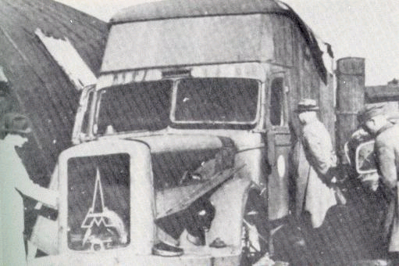
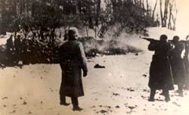
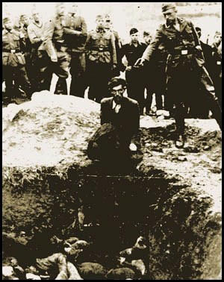
1941 – The Babi Yar Massacre – in 2 days nearly 35,000 Jews lined up alongside pre-dug pits and were shot to death.

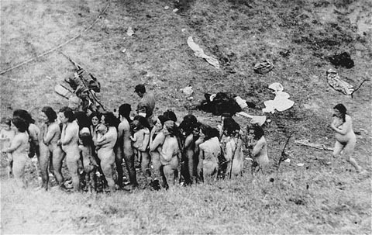
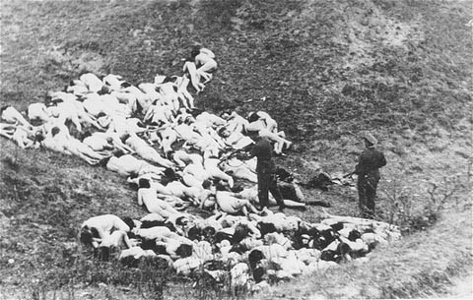
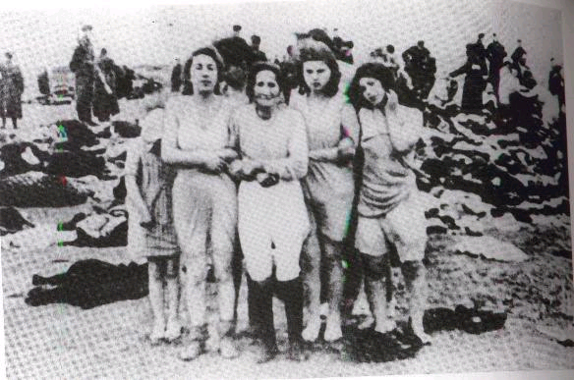
1942 - Wansee meeting of German officials to coordinate and organize an efficient system of mass extermination.
* 1942 – by the spring the Nazis had changed 6 concentration camps to extermination camps in Poland with the additions of gas chambers, burning grounds and crematoria.

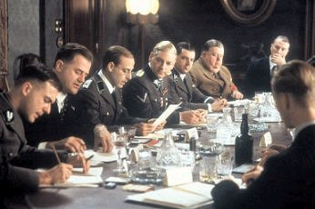
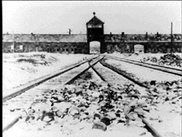
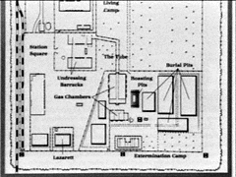
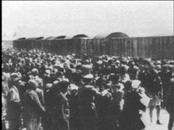
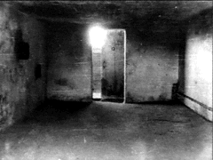
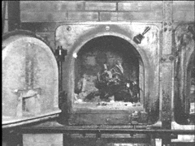
1944-45 – camps became liberated through the advancement of the Allied forces. The world now saw the true horror of the final solution.
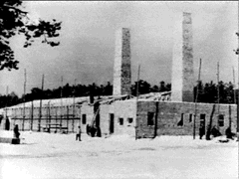
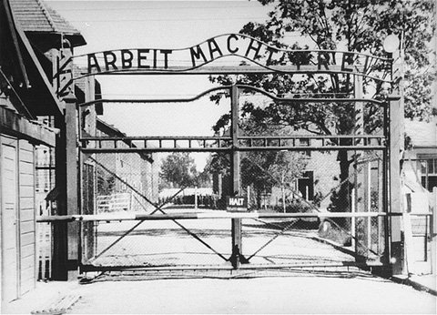
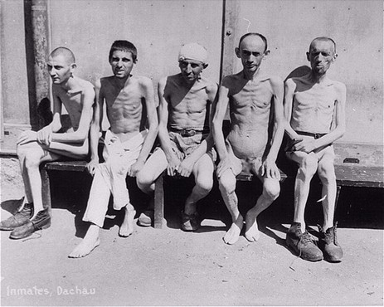

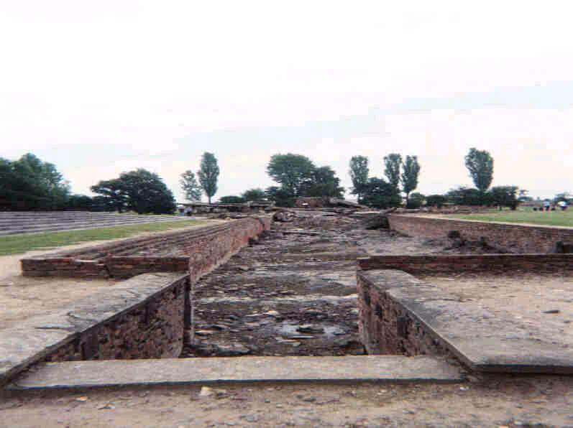
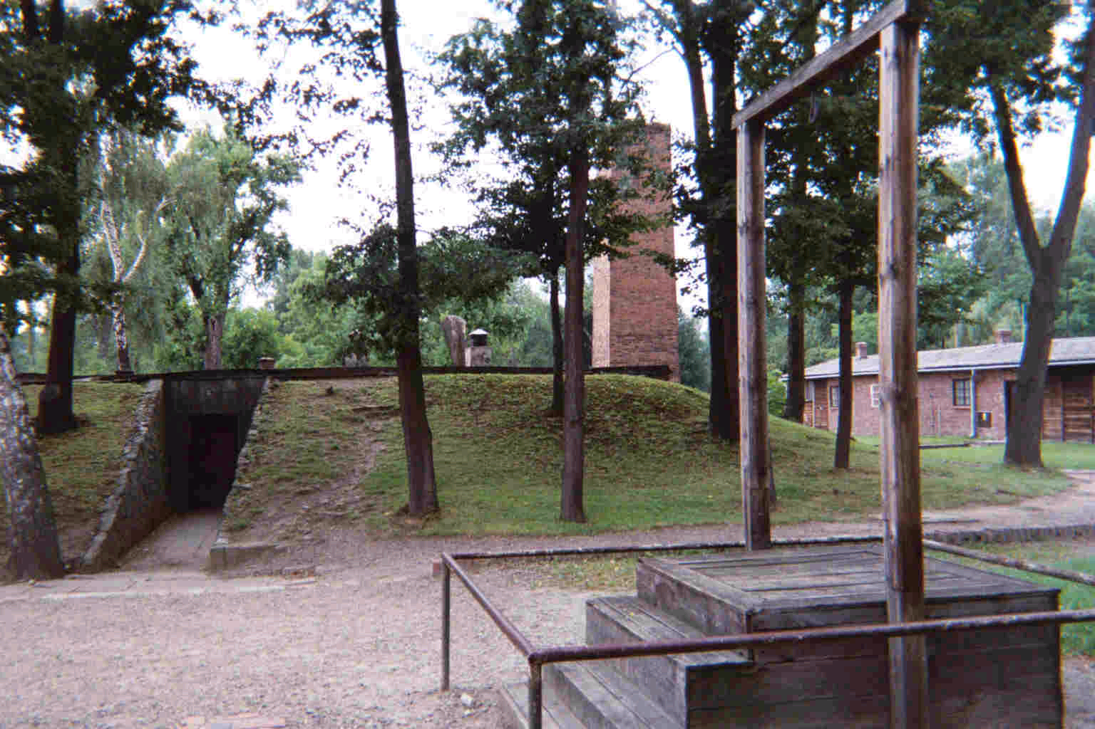
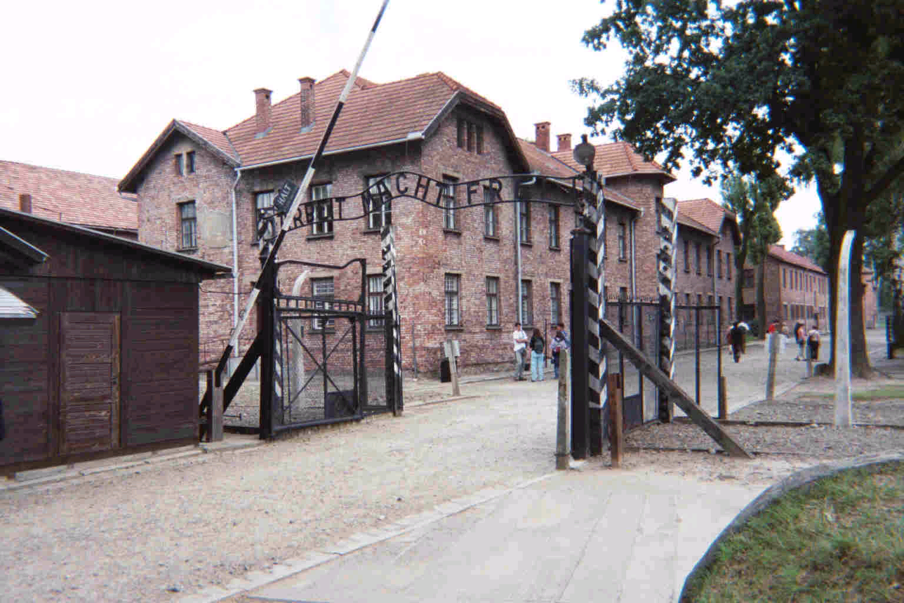

1946 – the Nuremberg trials: major Nazi leaders and generals were tried for crimes against humanity. Most were convicted and either executed or sentenced to life imprisonment.
Between 150,000 and 200,000 Nazi soldiers were responsible for the deaths over 6 million Jews, but only 3,500 were ever tried and convicted.
The concept of “I was only following orders,” became an unacceptable defense.



