Latin America and the Cuban Revolution

NOTES

- Background:

- Latin America had many problems in the Cold War period – USA has economically been Imperialistic in the region for many years – main fear = Communism.
- Slow agriculture, population growth, poverty, low education, and foreign ownership of land and companies caused slow individual country growth and development.
- Fear by the USA of Communist government led them to support many Authoritarian style governments or dictatorships.
- The USA would do anything to stop the spread of Communist groups.
- USA had sent arms to Honduras and Nicaragua to stop Communism.
- Argentina: Peron military ruler.
- Chile: CIA led coup to install Pinochet as leader in the 1970’s
- Countries were fertile ground for revolution due to discontent stemming from inequalities.

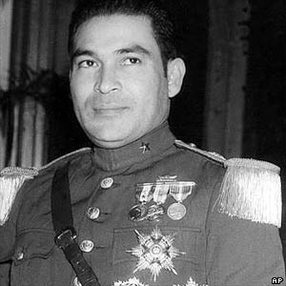
- The Cuban Revolution:

- Cuba was an American protectorate after the 1898 Spanish American War.
- Under the harsh pro-American dictator Batista, American Corporations exploited Cuban resources and workers.
- Deterioration in industry, health and education and increasing poverty made Cuba ripe for revolution.

NOTES:
- America treated Cuba as their little ‘Playground.’ Casinos, resorts, while the rest of the country suffered.
- All major businesses owned and controlled by American companies.

Fidel Castro

- Anti-American and anti-Batista, overthrew the government in 1958.
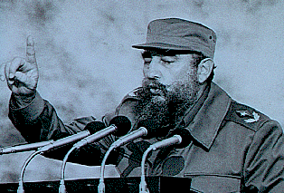
- An educated lawyer, Castro organized a revolutionary group who took over the country to free it from the shackles of American control and the corruption of Batista.
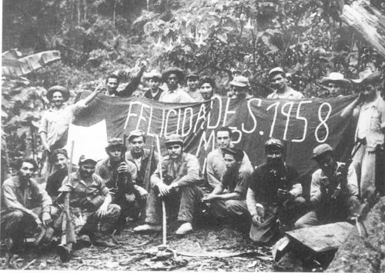

NOTES:

D) Why did the USA not crush the Revolution?

NOTES:

- American public would probably not support and invasion.
- No large Anti-Castro force to support.
- Economic pressure plus aid to Cuban Exiles would topple Castro anyway according to the State Department.
- Invasion would increase anti-American feeling elsewhere in Central America.
- USA had pledged not to invade Cuba.
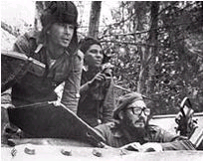
So – Castro….

- Nationalized USA owned companies (took them over, kicked Americans out).
- Received no aid from the USA obviously.
- Began closer ties with the USSR (Castro was not Communist until the USA cut off ties).
- Thousands of Cuban refugees fled to the USA.

The Bay of Pigs - http://www.youtube.com/watch?v=DoGESE_wO34

NOTES:

- 1961 – The CIA devised a plan to invade Cuba using CIA trained and supplied Cuban refugees.
- President Kennedy, approved the plan, but used the media to say the USA would not get involved.
- Air cover was supposed to be given to the invasion force by the USA.
- Kennedy cancelled the air support at the last minute fearing international reprisals.
- Poor planning and execution resulted in a fiasco, failure of the invasion, Castro defeated them easily.
- Kennedy told the public it was a spontaneous action by the exiles, but the truth leaked out, and Kennedy’s credibility greatly declined.
- Castro would now seek greater Russian support fearing an American invasion.

The Cuban Missile Crisis

Background

- Castro was forced into a political and economic corner by the USA.
- USA had put a trade embargo on Castro, hurt significantly.
- Castro feared American invasion due to the Bay of Pigs fiasco.
- Had to turn to the USSR for support, economic and military.

Discovery

NOTES:

- A U2 spy plane flying over Cuba discovers missile installations being constructed in Cuba.
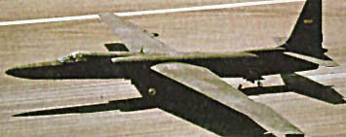
- No doubt that the USSR was setting up the sites.

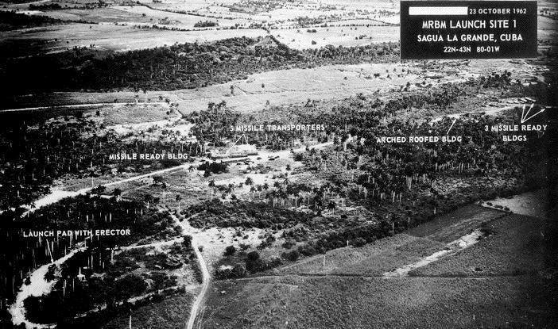

Issues

- The USSR was trying to install IRBM’s – Intermediate Range Ballistic Missiles, which could hit any target in the USA.
- The Soviets did not have the capacity for ICBM’s yet – Intercontinental Ballistic Missiles that could be launched from Russia to hit targets. The USA did.
- The Americans also had missiles under NATO in Turkey, threatening the USSR.

NOTES:
- Kennedy announced the discovery to the World on the TV.
The crisis would become known as the 14 days in October.
http://www.youtube.com/watch?v=P7YkJxQT_0Y
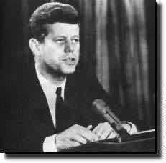

What to Do?

- Kennedy had three options: Air Strike – Invasion – Diplomacy (negioation).
- Kennedy chooses the use diplomacy with the threat of nuclear war.
He orders a Quarantine of Cuba, a complete naval blockade, attempting to stop any Russian vessels from delivering any missiles to Cuba.

- During the public phase of the Crisis, tensions began to build on both sides. Kennedy eventually ordered low-level reconnaissance missions once every two hours. On the 25th Kennedy pulled the quarantine line back and raised military readiness to DEFCON 2.

NOTES:
- Then on the 26th EX-COMM heard from Khrushchev in an impassioned letter. He proposed removing Soviet missiles and personnel if the U.S. would guarantee not to invade Cuba.
- October 27 was the worst day of the crisis. A U-2 was shot down over Cuba and EX-COMM received a second letter from Khrushchev demanding the removal of U.S. missiles in Turkey in exchange for Soviet missiles in Cuba.

Attorney General Robert Kennedy suggested ignoring the second letter and contacted Soviet Ambassador Anatoly Dobrynin to tell him of the U.S. agreement with the first.

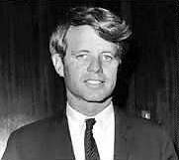

Results

- Khrushchev would pay a political price for backing down to Kennedy.
- The ‘Hot-line’ red phone would be installed in the White House for instant contact with the Soviet Premier.
- Crisis leads to the 1963 Nuclear Test Ban Treaty.
The world is saved from possible Nuclear War, probably the closest we have ever come to it.

The Nuclear Arms Race

NOTES:

- during the 1960’s, the USSR detonated A-bombs 2800 times powerful than the one dropped on Nagasaki
- socially, we now had the power to destroy ourselves completely
- as delivery systems became more sophisticated, the fear factor became more real
- in the free world the development of anti-war and anti-weapons movements, the ban the bomb movements or peaceniks
- Economically, billions of dollars were spent on research and development and testing, which meant less money for everything else. This would help in the collapse of the USSR.
- The development of the military industrial complex – companies run to produce weapons
- Politically, each side had to present themselves as superior, and in the USA politicians had to be aware of the electorate
- Militarily, each side produced scenarios which predicted the win ability of a nuclear war, even though we know it would have been futile
- It can be argued that the sheer terror of a nuclear war actually preserved peace
- The arms race created military alliances

Delivery systems

- in the early years, the air bomber was the only delivery system for the bomb
- with the space race (Sputnik) the ICBM was created
- then MIRV’s (Multiple Independently Targeted Re-entry Vehicles) then had the capacity to send up one rocket and release many warheads at different targets. This was to confuse defense systems.

NOTES:
- Nuclear powered submarines then could launch Polaris missiles, and stay underwater for months.
- Both sides eventually developed mobile missile systems such as the Pershing II and the Cruise missile.
- We have come full circle, from the machine gun to create a stalemate in WW I, defensive weapon, to mainly offensive weapons, to now with SDI (strategic Defense Initiative) Star Wars technology to shoot down oncoming missiles

MAD – Mutually Assured Destruction
SAC – Strategic Air Command – USA air force is in the air 24 hours a day with nuclear weapons to discourage a pre-emptive strike from a foe

Nuclear Non-Proliferation Treaty

- USSR and the USA signed a treaty which would limit the spread of nuclear weapons in 1968, by 1975 93 other countries had signed

Strategic Arms Limitations Talks

- began in 1969, by 1972 the first SALT Treaty (SALT I) limited the number if ICBM’s by both sides
- 1979 SALT II was ready, but the Soviet invasion of Afghanistan stalled talks, and once Ronald Regan took power in the USA Détente never had a chance, because he started another arms race

NOTES:

The Helsinki Accords

- 1975, the USA, USSR, France and the UK agreed to accept European frontiers including the Germany’s, to respect human rights and make movement of peoples across frontiers easier
- the Accords were the most significant accomplishment of Détente

We could argue that Détente was just Containment: Kissinger argued that they could make deals with the USSR while still containing them

Cold War – 1945-1963

Détente – 1963-1979

Cold War – 1979-1991

NOTES:

The Arms Race after SALT

- escalation of the arms race with the Soviet invasion of Afghanistan and Ronald Regan
- Regan called the USSR the Evil Empire, and would not negioate with them
- New wrinkles:
- Delivery systems and high tech: the Americans shot ahead in computer delivery technology
- The Cruise Missile: a pilotless, very small airplane carrying a nuclear warhead, very sophisticated guidance system using an on-board computer which has memorized the best route to the target, flying 50 feet off the ground to avoid radar. USA deployed them in Europe and on ships.
- The Smart Weapons: targeted and controlled by computers, A-WACS were a plane that could control the weapons while in air, weapons would be guided to their destination.

- SDI (Strategic Defense Initiative) Star Wars proposed to develop a defensive umbrella over the USA to prevent incoming missiles from reaching their targets, the Pentagon and Regan tried to convince the public that is was based on science, a proposal saw a large laser system suspended in space which would vaporize any incoming missile, this would upset nuclear parity and worried the Soviets about an American pre-emptive strike, and the Soviets could not afford the technology.

http://www.youtube.com/watch?v=1YnHjg2ouio&feature=related

