OSCAR WINNER 1993:
Best Picture Best Film Editing
Best Director Best Original Score
Best Screenplay Adaptation Best Art Direction
Best Cinematography

Today is history
Today will be remembered.
Years from now, the young will ask with wonder about this day.
Today is history and you are part of it. Six hundred years ago when, elsewhere, they were footing the blame for the Black Death Kazimierz the Great, so called, told the Jews they could come to Cracow.
They came.
They trundled their belongings into the city They settled, they took hold, they prospered.
In business, science, education, the arts. They came here with nothing, and with nothing they flourished.
For six centuries, there has been a Jewish Cracow.
Think about that.
By this evening, those six centuries are a rumor.
They never happened.
Today is history.
If you have seen the film SCHINDLER’S LIST then you might recognize the words printed above. They are spoken by the commandant of the Plaszow Concentration Camp at Plaszow, Amon Goeth, a central character in the story of Oskar Schindler. Goeth actually existed and was the commandant of Plaszow Concentration Camp in Poland.
Read the speech again. Whilst such speeches may have been created for the film, in your study of History and the history of the Second World War, how do they create an impression of what happened to the Jews and the reasons for the way in which they were treated by the Nazis? 3 Marks
________________________________________________________________________________________________________________________________________________________________________________________________________________________________________________________________________________________________________________________________________________________________________________________________________________________________________________________
Task 1 – 5 Marks
Look carefully at the following sources:

SOURCE A
Their synagogues should be set on fire and whatever does not burn up should be covered or spread over with dirt so that no one may ever be able to see a stone of it. ... Their homes should be broken down and destroyed passport and travelling privileges should be absolutely forbidden to the Jews ... all their cash and valuables should be taken from them. To sum up ... if this advice of mine does not suit you, then find a better one and we may all be free of this insufferable devilish burden the Jews.

SOURCE B
I must certainly regard the Jewish race as the born enemy of pure man and of all nobility in them and am convinced that we Germans in particular will be destroyed by them.

SOURCE C
This worldwide Jewish conspiracy for the overthrow of civilization and for the reconstitution of society on the basis of arrested development ... has been steadily growing.

SOURCE D
Should the Jew ... triumph over the people of this world, his crown will be the funeral wreath of mankind, and this planet will once again follow its orbit through ether, without any human life on its surface, as it did millions of years ago. And so I believe that my conduct is in accordance with the will of the Almighty creator. In standing guard against the Jew I am defending the handiwork of the Lord.
One of these four sources comes from Hitler’s book “Mein Kampf” (My Struggle) published in 1925. Can you tell which one? __________________The others were written in - 1543, 1881 and 1920. Can you sort out the different sources into their correct order? ________________________________________________________________________________________________________________________________________________________________________________________________________________________________________________________________________________________________________________________
Finally, one of them appeared in an English newspaper. Can you tell which one? ________________________________________
The fact that nearly 400 years span the four quotations yet all four of them seem to be saying the same thing should point out that anti-Semitism was nothing new when Hitler came to power in 1933. Yet until Hitler there had been no attempt at the total extermination of the Jewish race in Europe.
--------------------------------------------------------------------------------------------------------------------------------------------------
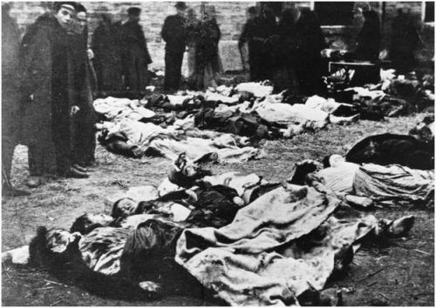
Task 2 – 5 Marks

For you to try and research the complete history of Jewish persecution would be impossible. In order to understand both the myths that have circulated over the centuries about the Jews and also some of the ways in which they have been treated, you should try to find out about the following:
1. The Diaspora: _________________________________________________________________________________
2. The Blood Libel: _______________________________________________________________________________
3. Treatment of Jews by the Spanish Inquisition: _______________________________________________________
_________________________________________________________________________________________________
4. The Settlement of the Pale: _____________________________________________________________________
5. Pogroms.: ___________________________________________________________________________________
These five areas, covering a wide period of history, should give you the sense that anti-Semitism was not simply confined to Germany in the 1930’s - 40’s but was spread across Europe over many centuries. What it is now crucial to examine is the situation in Germany which gave rise to Hitler’s desire to exterminate all Jews and the development towards what is termed ‘The Final Solution’.
-------------------------------------------------------------------------------------------------------------------------------------------------------------

Task 3 – 5 Marks
Look at the two sources below:
SOURCE A
Members of the Police were, with a few exceptions, quite happy to take part in the shooting of Jews. They had a ball! Obviously they won’t say that today. Nobody failed to turn up ... I want to repeat that people today give a false impression when they say that the actions against the Jews were carried out unwillingly. There was great hatred against the Jews; it was revenge, and they wanted money and gold. Don’t let’s kid ourselves, there was always something up for grabs during the Jewish actions. Everywhere you went there was something for the asking. The poor Jews were brought in, the rich Jews were fetched and their homes were scoured.
Polish Police official, Krakow District 1941
SOURCE B
All the men coped with the tough physical stress well. No less considerable were the extreme psychological demands made on them by the large number of liquidations. The morale and self-possession of the men was kept up by personally reminding them constantly of the political necessity of what they were doing.
Day book of Einsatzgruppe One, 31 July 1941

In what ways are the motivations of the two groups involved in the persecution of the Jews different?
____________________________________________________________________________________________________________________________________________________________________________________________________________
----------------------------------------------------------------------------------------------------------------------------------------------------------------------

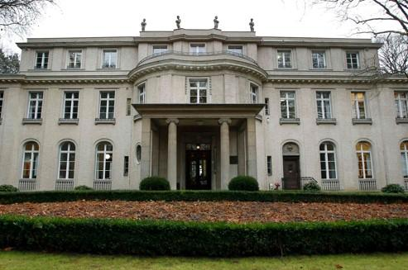
Task 4 – 5 Marks

Read the text of the Wannsee Conference which refers to the Final Solution. How does this mark a change in the proposed treatment of the Jews? : ______________________________________________________________________________________________________

______________________________________________________________________________________________________

- EXTRACTS FROM WANNSEE DOCUMENT –
In view of the dangers of emigration in war-time, and the possibilities in the East, the Reichsführer 55 and Chief of the German Police (Himmler) has forbidden the emigration of Jews.
Emigration has now been replaced by evacuation of the Jews to the East, as a further possible solution, with the appropriate prior authorization of the Führer.
However, this operation should be regarded only as a provisional option; but it is already supplying practical experience of great significance in view of the coming final solution of the Jewish question.
The Jews are to be utilized for work in the East in an expedient manner in the course of the final solution. In large (labour) columns, with the sexes separated, Jews capable of work will be moved into those areas as they build roads, during which a large proportion will no doubt drop out through natural reduction. The remnant that eventually remains will require suitable treatment; because it will without doubt represent the most (physically) resistant part, it consists of a natural selection that could, on its release, become the germ-cell of a new Jewish revival (witness the experience of history).
Europe is to be combed through from West to East in the course of the practical implementation of the final solution. ... The evacuated Jews will first be taken, group by group, to so-called transit ghettos, in order to be transported further east from there.
Until 1941 Jews had been used for forced labour in camps or taken from the ghettos in forced labour details. The camps from this time onwards, however, developed a more sinister character - they became death camps, converted for the ultimate destruction of the Jewish population of Europe.

How is this reflected in the treatment of the Jews of Krakow as seen in SCHINDLER’S LIST? (after viewing)
__________________________________________________________________________________________________________________________________________________________________________________________________________________________________________________________________________________________________________________
Task 5 – 5 Marks

When you have seen SCHINDLER’S LIST, try to say what impression was given of life in the ghetto? What were the key things needed to survive? What were the main problems that the Jewish population of the ghetto had to face?
________________________________________________________________________________________________________________________________________________________________________________________________________________________________________________________________________________________________________________________________________________________________________________________________________________________
Task 6 – 5 Marks
Oskar Schindler arrived in Krakow in late 1939. From what you have seen in SCHINDLER’S LIST, what seem to have been the things that attracted him to Krakow? What did he hope to do in his time in the city?
________________________________________________________________________________________________________________________________________________________________________________________________________________________________________________________________________________________________________________________________________________________________________________________________________________________
Conclusion – 20 marks
Now that you have worked through the various tasks in this study guide, try to answer the following questions:
1. Compare the film with your own study/knowledge of the historical period shown.
a) Which scenes in the film illustrate areas you have explored?
__________________________________________________________________________________________________________________________________________________________________________________________________________________________________________________________________________________________________________________
b) How has the film added to your understanding of the period?
__________________________________________________________________________________________________________________________________________________________________________________________________________________________________________________________________________________________________________________

c) Are there any major areas you consider relevant to an understanding of this period which are not addressed in the film?
__________________________________________________________________________________________________________________________________________________________________________________________________________________________________________________________________________________________________________________
2. How does the film represent the main historical characters and groups? Why do you think they were represented in the way they were?
__________________________________________________________________________________________________________________________________________________________________________________________________________________________________________________________________________________________________________________
3. What evidence does the film provide about the period in which it was made?
__________________________________________________________________________________________________________________________________________________________________________________________________________________________________________________________________________________________________________________
4. Draw up a list of the advantages and disadvantages of the film as a resource for historians.
________________________________________________________________________________________________________________________________________________________________________________________________________________________________________________________________________________________________________________________________________________________________________________________________________________________

